## Configure PowerPoint (QRC)

## Introduction

The Configure PowerPoint QRC shows how to set up the optimal configuration to utilize the EMAF PowerPoint files on ExxonMobil PCs and for storing the artifacts on the EMAF Architecture Repository.

## Configure PowerPoint Instructions

### Create **My Templates** Folders

If Configure Visio QRC was not completed: From File Explorer, navigate to your network account **c:\users\<your network id>\LocalData** folder, and create the folder called **My Templates**

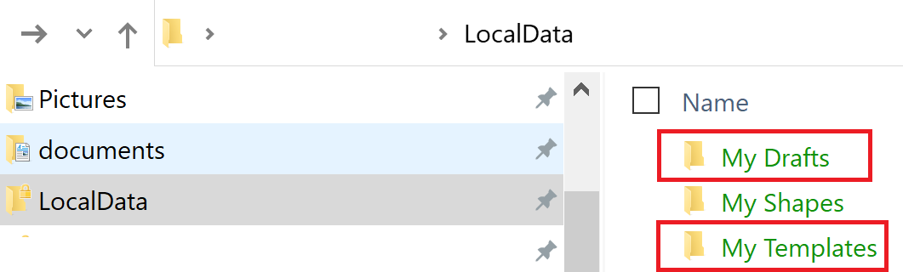

### To configure PowerPoint to use **My Templates** Folders

1. In PowerPoint, click the **File** Menu

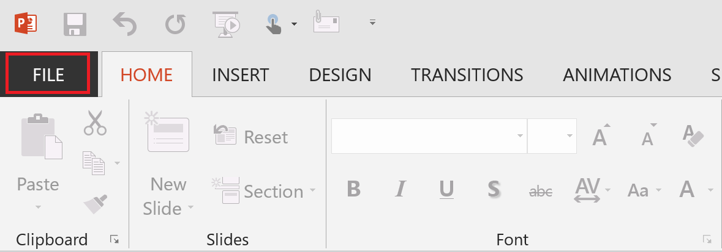

1. Click the **Options** Sub-menu

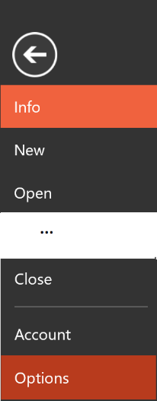

1. Once the Excel Option dialog box is displayed, click the **Save** option

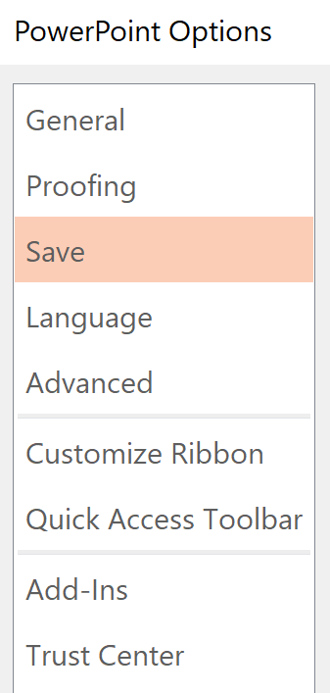

1. Configure the **Templates** Folders

* Click into the “Default personal templates location”, then set the path to your **localdata\My Templates** folder
* Click the **OK** button

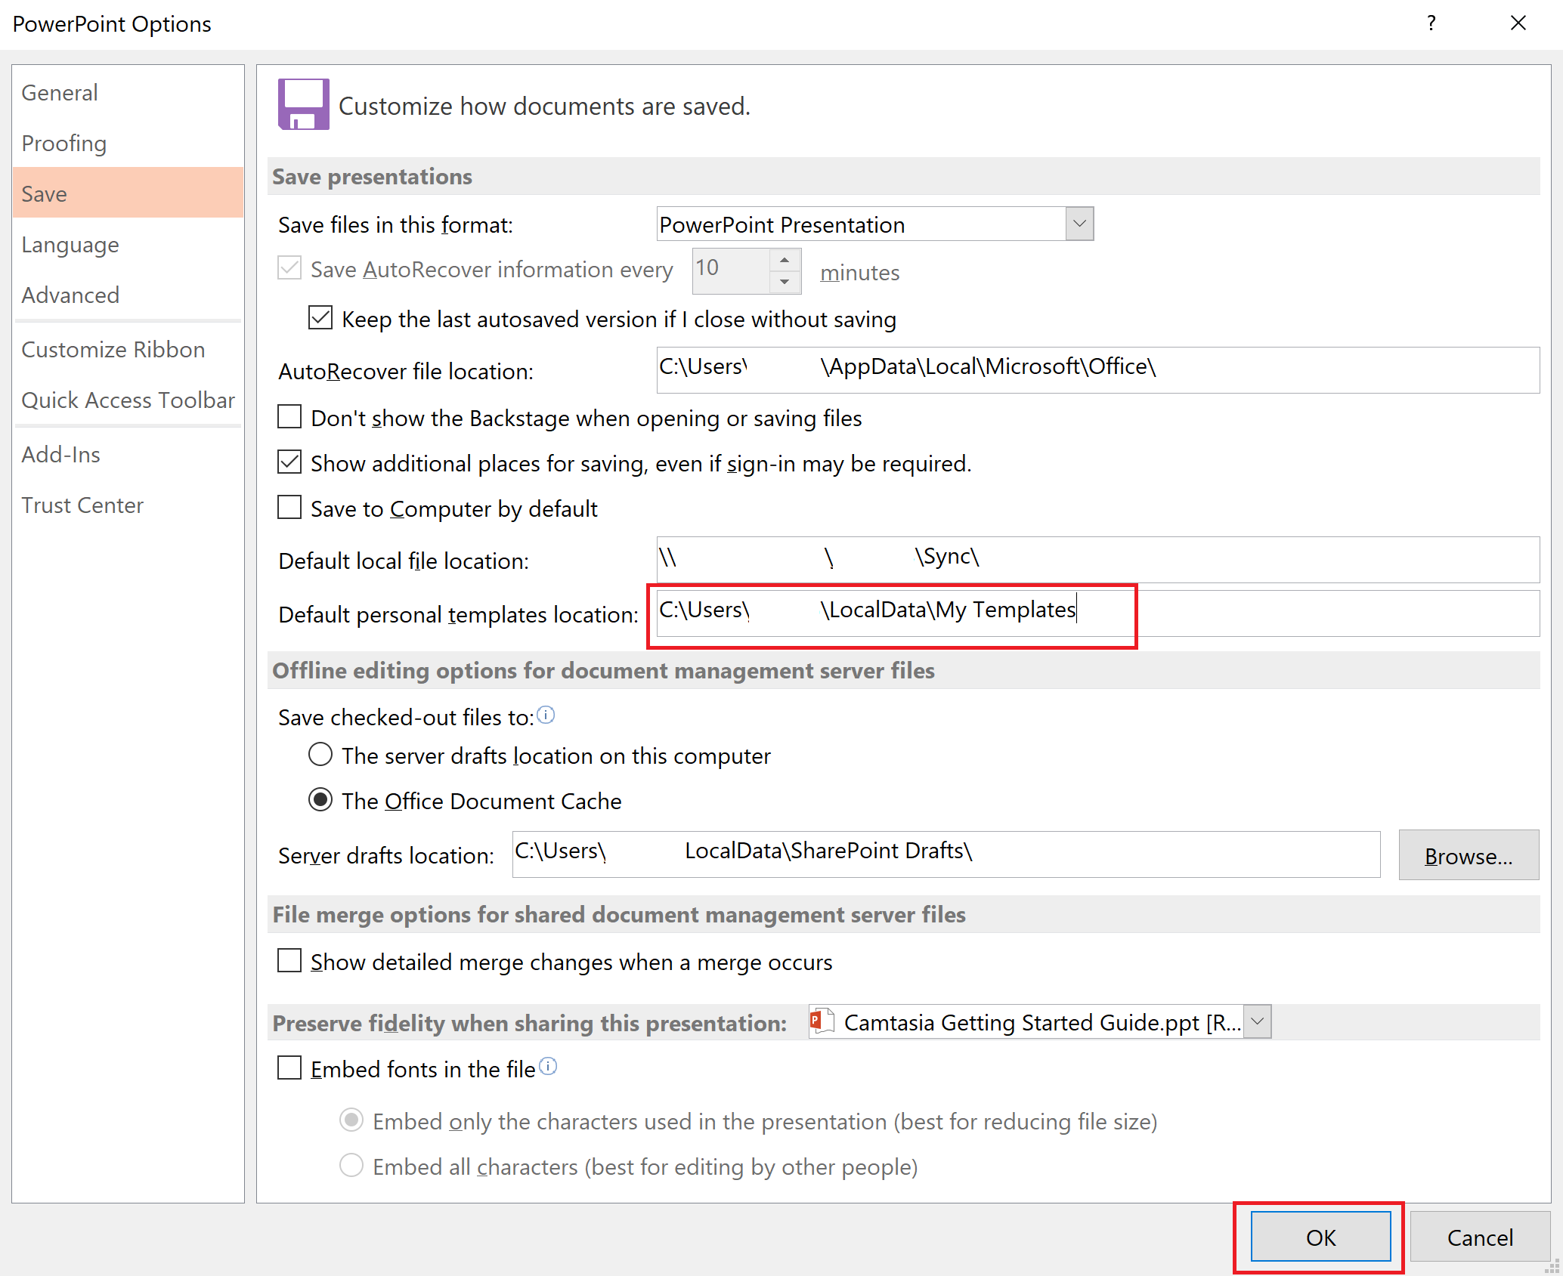

**NOTE: When you create a new artifact (File -> New -> Custom -> My Template), all EMAF templates will be displayed**

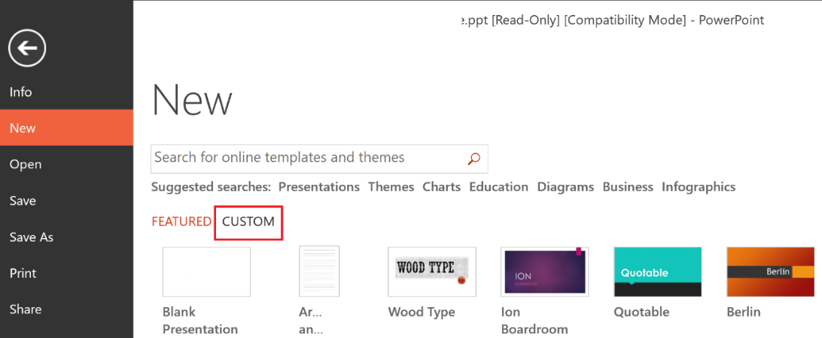

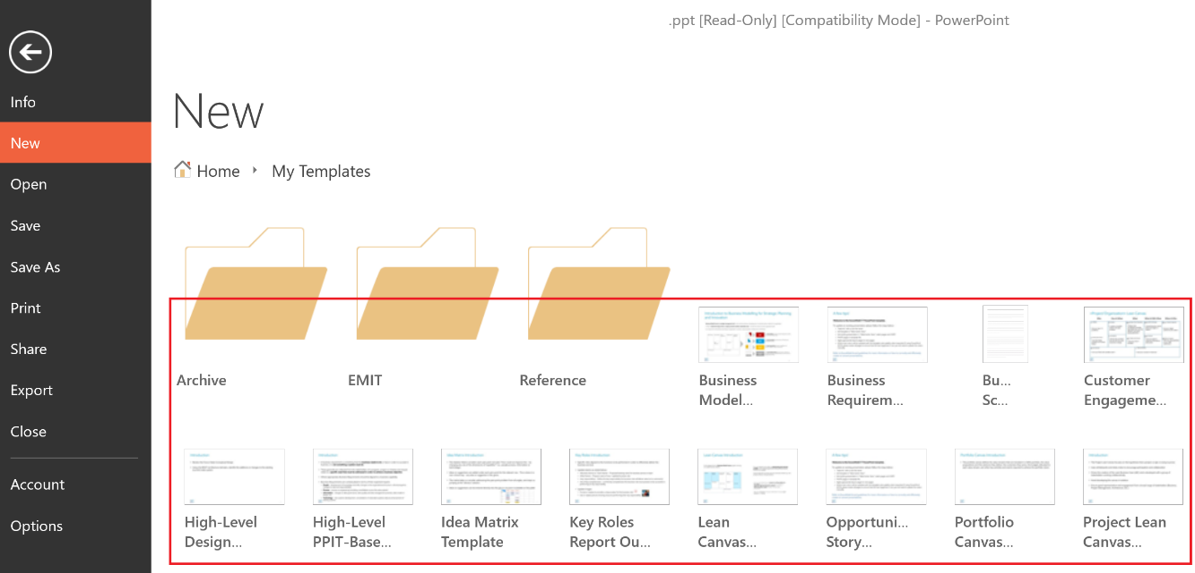

### To pin other EMAF Architecture Repository Targets

Once you have begun opening or saving PowerPoint documents to folders in the EMAF Architecture Repository, these folders will begin appear under your Recent Folders area which you can then pin these locations for a quick and convenient way to access these locations in the future.

1. In PowerPoint, click the **File** Menu



1. Click either the **Open** or **Save As** Sub-menu, click **SharePoint**, then under the **Recent Folder** area select the SharePoint location and click the **Browse** button

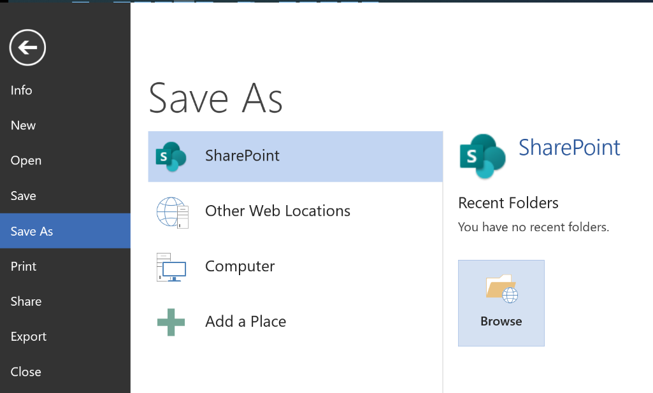

1. Within the Open dialog box

* Copy/paste the following URL into path field: <https://ishareteam4.na.xom.com/sites/Architect/Architecture%20Repository>
* Select the following file: **Use-For-Setting-Up-PowerPoint**
* Click the **OK** button

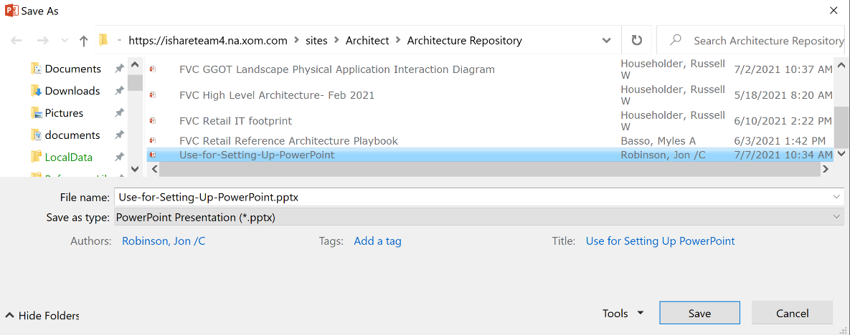

1. Now that the goto/ArchRepo path has been registered within your PowerPoint client, perform the following steps

* Navigate to **File -> Open -> SharePoint -> Recent Folders**
* Right mouse click on the **Architecture Repository** entry
* Select **Pin to List** option

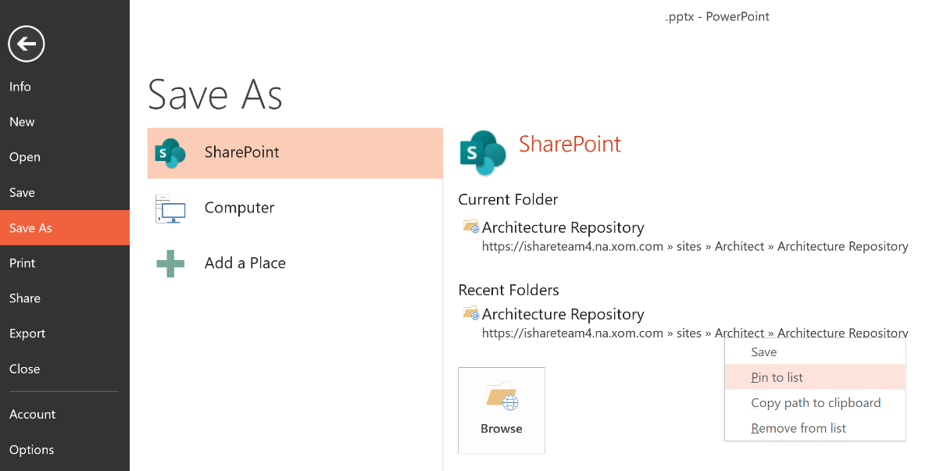

1. To use the pinned locations, simply

* Navigate to **File -> Open -> SharePoint** or **File -> Save As -> SharePoint**
* Click the pinned location you want to use
* Click the Browse Button



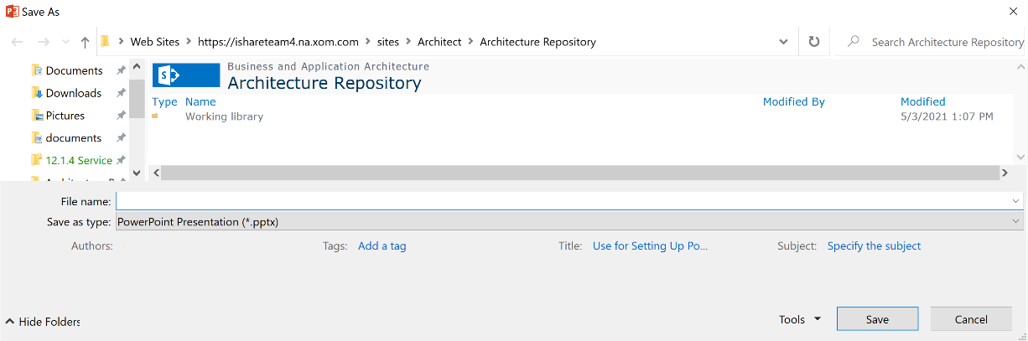

**NOTE: Repeat steps 1-6 for your project / architecture repositories located under Working Library.**